**Python Game**

Using python we can build a lot of stuff, application, games, sites, etc.. My project will be on a game that I have always enjoyed playing on my phone. Its called “ballz”, where the player starts with one ball and he can shoot it at the bricks on top of the screen, each brick has a number on it that number indicates the durability of the brick, how many hits it would take to break this brick. Moreover, every time the player shoots the ball the blocks descend by one block down and more blocks are added on the top. As the player breaks more blocks the blocks will have higher durabilities.

**Before first shot:**

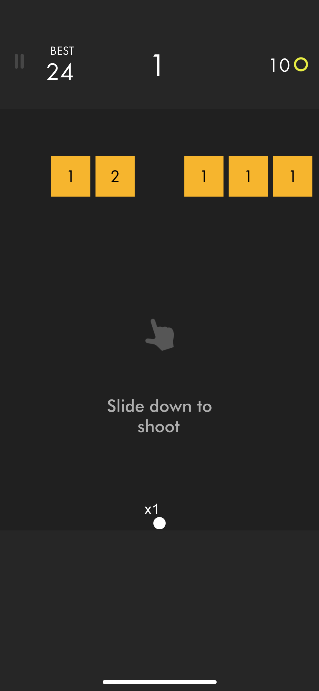

**After the shot has been taken:**

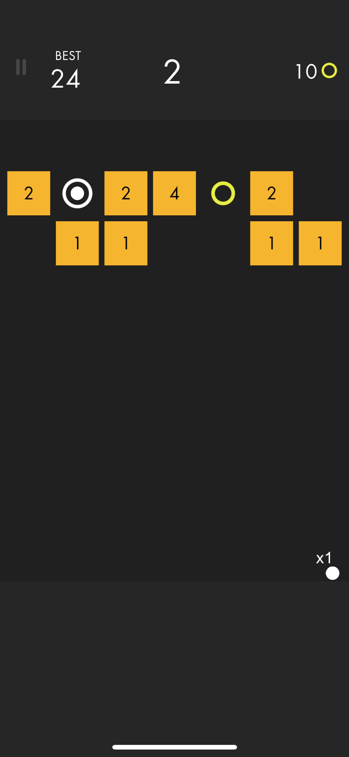

There will be certain circles when taken will increase the number of balls you shoot at once, which will make the player proceed and play more.

There will be a counter in the middle of the screen that will count how many times did you play and as you play more before the blocks touch the line where you shoot the ball, you will have more points.

In the end, the user will be able to fully experience this fun game.

I will either use tkinter or pygame or pygame zero (still not sure).

* The user will be able to see how many hits can each block take
* There are collectible circles that will add towards the balls to be shot.
* There are yellow coins to be collected and used to purchase new themes (backgrounds).

By the first deadline, I should have finished the interface of the game. The background, the window, the shop that the player should be able to buy themes from.

In the end, the user should be able to fully experience this fun game and play it as long as he/she wants to.

* The player should play the game at it’s full, as long as he didn’t lose.
* The game should be fully functional and available to be played.